Screenshots for project:

1) Home Screen with data and action buttons (New Ticket, Edit, Delete, View)
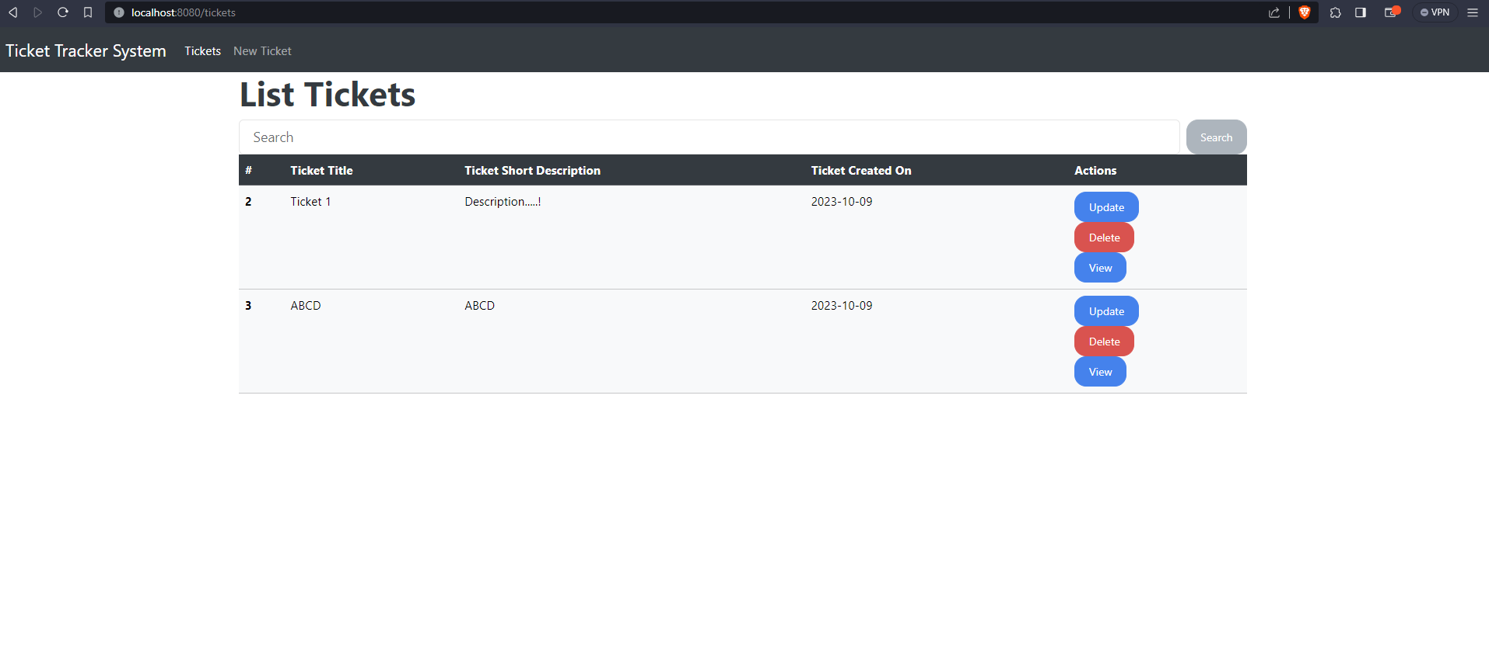
2) Edit Page
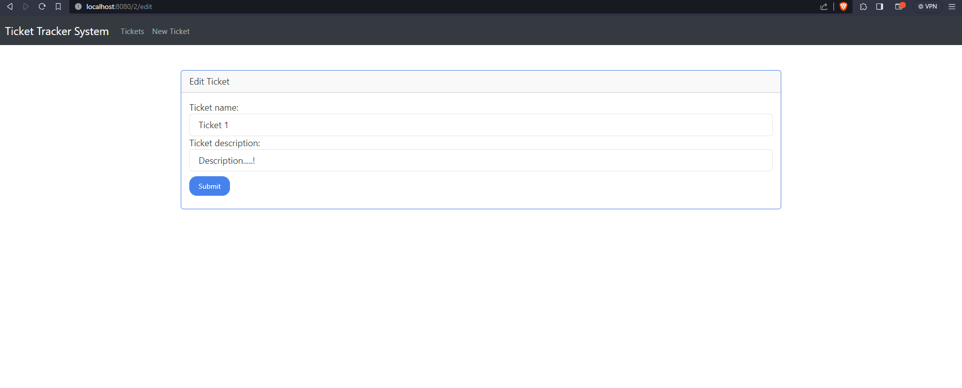
3) Create Ticket Page
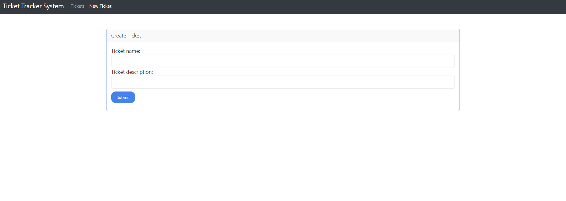

4) Ticket Search Function
